Machine Learning Decision Tree Project
The dataset used is Future50 dataset from Kaggle datasets.
The columns contains 'Rank', 'Restaurant', 'Sales', 'Units', 'Unit_Volume', 'Franchising'
The X=df[['Sales', 'Units', 'Unit_Volume']]
Y=df['Franchising']
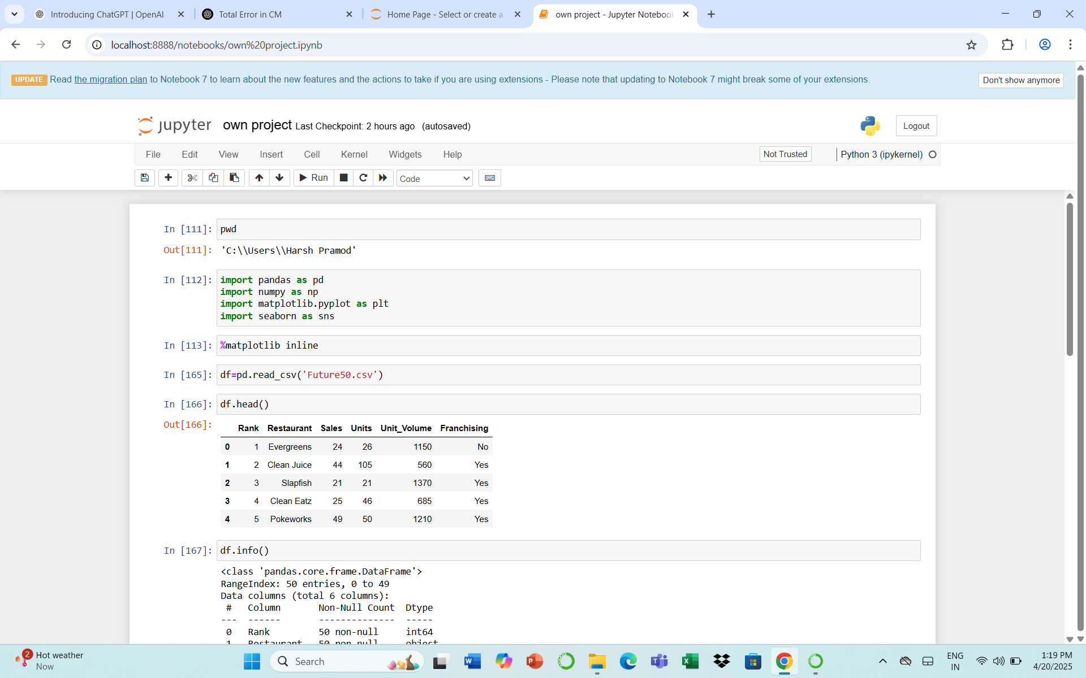
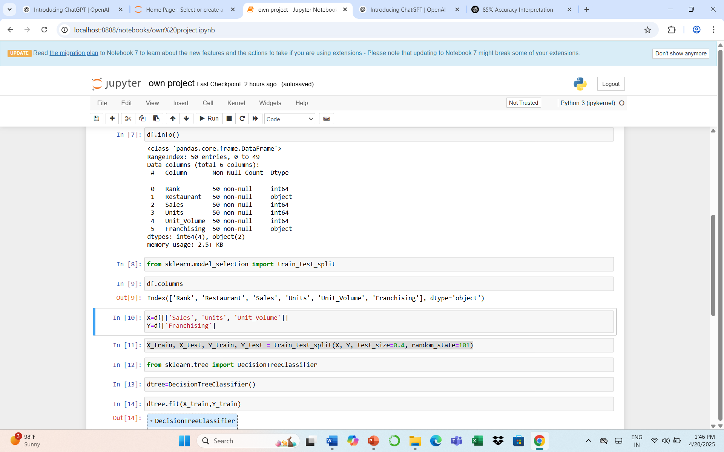
Training the model
Here , test_size is 0.4 which means 40% data is going for testing and 60% for training.
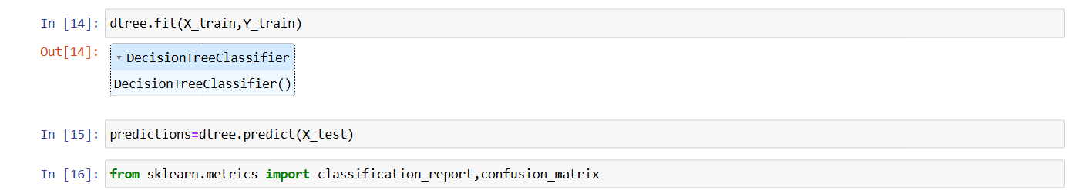
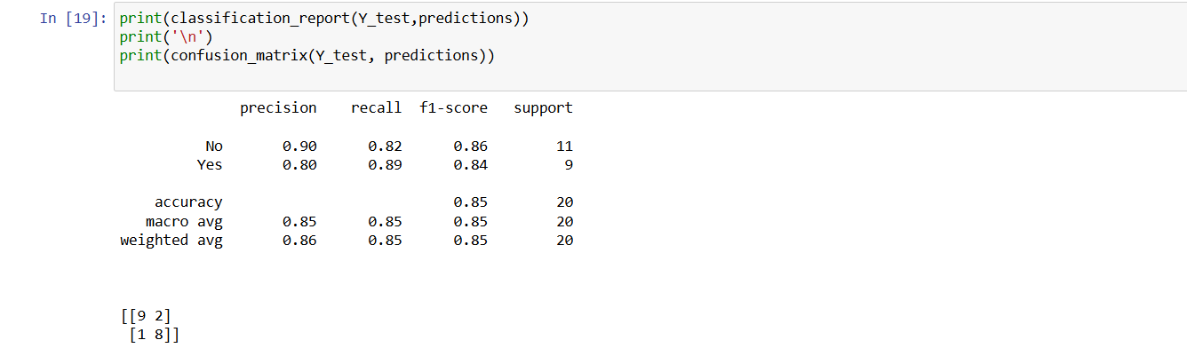

Confusion matrix analysis and interpretation
[[9 2]
[1 8]]
TN FP
FN TP
Where,
TN=True Negative
FP=False Positive (Type 1 error)
FN=False Negative(Type 2 error)
TP=True Positive
Accuracy=TP+TN/total
=9+8/20*100= 85%
Accuracy=85%
Total error= FP+FN/100
=1+2/20=3/20*100
=15%
Total error=15%
Here 85 are correct and 15 are incorrect predictions out of 100.
Overall 85% is a Good fit data, but needs improvement.
Above 90% is considered best fit.
Classification Report
Precision is the total accuracy of the model= 0.86
86%
Recall = 85% of True Positive calculated by model is accurate
F1 Score is the balance between precision and recall. The best F1 score is above 0.8
Here, the F1 score is 0.85 , 85% which is best F1 score for the data

